

Safeguarding and Protecting Children Procedures

Bluebells of Ratby is committed to safeguarding & protecting all children.
Staff will work with children, parents, external agencies, and the community to ensure the welfare and safety of children and to give them the very best start in life.
Children have the right to be treated with respect and to be safe from any abuse in whatever form.
To this end we will:
• Always listen to children, protecting them from maltreatment.
• Ensure children’s good health and development
• Create an environment to encourage children to develop a positive self-image
• Work to enable children to have optimum life chances and to enter adulthood successfully
• Encourage children to develop a sense of independence and autonomy in a way that is appropriate to their age and stage of development
• Provide safe and secure environment for all children
- Have regard for & implement The Fundamental British values into our practice
- Staff will be aware of & respond to any concerns of children or families supporting violent extremism or terror groups (PREVENT)
As a staff team we have a clear commitment to safeguarding children and promoting welfare.
Should anyone believe that this policy is not being upheld, it is their duty to report the matter to the attention of the manager/committee at the earliest opportunity.
The legal framework for this policy is based on:
• 1989 and 2004 Children’s Act
• Safeguarding Vulnerable Groups Act (2006)
- The Statutory Framework for the Early Years Foundation Stage (EYFS 2021)
- We also have regard to ‘Working Together to Safeguard Children’ 2017 guidance
- Keeping Children Safe in Education

As practitioners we recognise that we have a duty to safeguard and promote the welfare of the children in our setting.
The setting has a duty to be aware that abuse does occur in our society.
Our prime responsibility is the welfare and wellbeing of all children in our care.
Staff must continually show their ability and confidence of dealing with any concerns or information regarding to any aspect of safeguarding children by completing their individual competency framework.

Designated safeguarding lead officers at the setting -Manager & Deputy Manager.
The Designated Safeguarding lead officers take the lead responsibility for safeguarding children within the setting and are responsible for liaison with local statutory children’s services agencies and with the Local Safeguarding Children’s Partnership. The lead officers provide support, advice, and guidance to all staff members on a regular basis and on any specific safeguarding issue as required. If there is any concern regarding a child’s wellbeing this must be passed on to the designated lead officers in order that the appropriate level of support and record keeping is assured.
Identifying concerns
Adults within the setting may be the first people to identify a concern with a child or a family and it is of vital
importance that all concerns be raised immediately and recorded appropriately.
Should a member of staff have a concern about a child or family they must:
• Share their concern with the lead officer
• Make a record of their concern and any consequential conversations regarding the concern
• Speak to the child’s parent/carer, unless doing so would be seen to be putting the child at increased risk of harm
• Ensure all records are stored securely and confidentially in accordance with GDPR
• Maintain a professional level of confidentiality only sharing information with practitioners who need to know in order to safeguard the child

What should staff members report?
Some examples of what would need reporting in terms of safeguarding might be:
• Significant changes in a child’s behaviour and/or development
• Any unexplained bruising or marks
• Comments which give cause for concern
• A deterioration in a child’s wellbeing
• Irregular attendance and/or frequent time away from the setting
• Concerns about the behaviours/language of parents/carers during drop of/collection
• Children continually appearing unkempt, hungry or without appropriate dress for the weather
• Language or behaviour of a sexual nature
We are prepared to act if we have concerns about the welfare of a child who fails to arrive at a session when expected. The designated person will take immediate action to contact the child’s parent to seek an explanation for the child’s absence and be assured that the child is safe and well. If no contact is made with the child’s parents and the designated person has reason to believe that the child is at risk of significant harm, the relevant professionals are contacted immediately and LRSB procedures are followed. If the child has current involvement with social care the social worker is notified on the day of the unexplained absence.
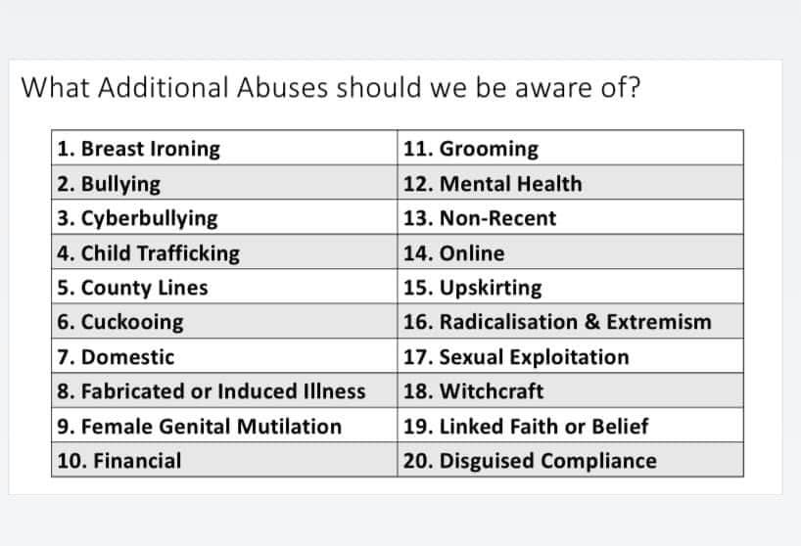
Recording concerns
Staff members will complete the following forms when necessary:
• Existing injury form – will be completed if a child arrives at the setting with an injury occurred away from
the setting
• Accident form – will be completed if a child is involved in an accident whilst at the setting or in our care.
This will be shown to and signed by parents/carers on collection
• Incident form – will be completed for all significant incidents involving a child within the setting.
This should be shown to and signed by parents/carers on collection unless sharing the information may
put the child at risk of harm
All incidents must be dated and contain a full account of the incident, including the child’s own words where applicable. All records are securely stored and monitored/audited regularly to check for trends and/or commonalities.
Supporting a child through a disclosure
If a child discloses information to a member of staff, it is important that staff members:
• Say and do things to show they are listening
• Say things to reassure the child and acknowledge their feelings
• Say you know someone who will be able to help
• Comfort them and tell them it’s good that they have told you
• Observe behaviours and record exactly what is said and done
• Ensure any actions do not further endanger the child
• Treat the child as before, as an equal
Staff members must not:
• Show visible shock or disbelief
• Give an interpretation
• Give or suggest information that the child hasn’t offered
• Agree to keep a secret
• Make a promise the abuse will stop
Making a referral
At the setting it would usually be the designated safeguarding leads who would make a referral using a Multi-Agency Referral Form (MARF), however, anyone who has concerns about a child’s welfare can and must ensure a referral is made to local authority children’s social care and should do so immediately if there is a concern that the child is suffering significant harm or is likely to do so. Urgent Referrals can be made to The First Response Children’s Duty Team 0116 3050005 who are available 24 hours a day. Practitioners who make a referral should always follow up their concerns if they are not satisfied with the response

Allegations against a staff member
In order to manage allegations against childcare professionals, every Local Authority appoints a Local Authority
Designated Officer (LADO). The LADO works within Children’s Services and should be alerted to all cases within 24 hours, in which it is alleged that a person who works with children has:
• behaved in a way that has harmed, or may have harmed, a child
• possibly committed a criminal offence against children, or related to a child, or
• Behaved towards a child or children in a way that indicates s/he may pose a risk to children. (Working
Together 2018)
- Ofsted will be notified of any allegations made within 14 days using the online Early Years Incident form
In this context, the term “professional” includes paid employees, volunteers, casual/agency staff and self-employed workers who will have contact with children as a part of their role. The LADO ensures that all allegations or concerns about professionals or adults working or volunteering with children are recorded appropriately, monitored, and progressed in a timely and confidential way. The LADO is involved from the initial phase of the allegation through to the conclusion of the case. The LADO provides advice and guidance to employers and voluntary organisations, liaising with the police and other agencies and monitoring the progress of cases to ensure that they are dealt with as quickly as possible, consistent with a thorough and fair process Any allegation must be reported immediately to a member of the management team who will inform the designated safeguarding lead practitioner. The LADO must also be informed within one working day of all allegations that come to an employer’s attention or that are made directly to the police.
• All cases will be subject to an initial joint evaluation between the LADO and referring agency, involving
relevant sectors as and when appropriate including, the Police, Children’s social work services,
employers and regulatory bodies. The assessment will focus on the nature of the concern, safeguarding for the child/children and appropriate consideration for the professional/volunteer involved.
An allegations management meeting will be convened where necessary to agree an appropriate way
forward.
• The protection of a child/young person will be the prime consideration in the process of managing an
allegation. The child/young person’s involvement in the process including support and feedback will be given careful consideration with the LADO ensuring that the child’s voice is heard.
• For the professional involved, the assessment and subsequent action will be stressful whatever the outcome and support for each individual must be considered and acted upon.
• If an organisation removes an individual (paid worker or unpaid volunteer) from work such as looking
after children (or would have, had the person not left first) because the person poses a risk of harm to children, the organisation must make a referral to the Disclosure and Barring Service. The contact details for the Local Authority Designated Officer are: Kim Taylor(0116) 30556541

Informing parents
- Parents are normally the first point of contact. Concerns are discussed with parents to gain their view of events, unless it is felt that this may put the child at risk or interfere with the course of a police investigation. Advice will be sought from social care if necessary.
- Parents are informed when we make a record of concerns in their child’s file and that we also make a note of any discussion we have with them regarding a concern.
- If a suspicion of abuse warrants referral to social care, parents are informed at the same time that the referral will be made, except where the guidance of the Local Safeguarding Children’s Partnership Board does not allow this, for example, where it is believed that the child may be placed at risk.
- This will usually be the case where the parent is the likely abuser.
- If there is a possibility that advising a parent beforehand may place a child at greater risk (or interfere with a police response) the designated person should seek advice from children’s social care, about whether or not to advise parents beforehand, and should record and follow the advice given.

